Natural Language Processing

Representation and Understanding
- Most words have multiple meaning - called as senses
- Cook - has a sense as a verb as well as a noun
- Dish - as a noun and as a verb
- Useful representation languages have two properties:
  - representation must be precise and unambiguous
  - representation should capture intuitive structure of NL sentences that it represents

Syntax - Representing Sentence Structure
- Syntactic structure of a sentence indicates the way that words in the sentence are related to each other
- NLP should be able to understand ill-formed sentences
- Example:
  - John sold the book to Mary
  - The book was sold to Mary by John
  - After it fell in the river, John sold Mary the book
  - After it fell in the river, the book was sold to Mary by John
  - * John are in the corner
  - * John put the book
- Languages are based on the notion of CFG, representing sentence structure in terms of what phrases and subpar of other phrases
  - Flying planes are dangerous
  - Flying planes is dangerous

The Logical Form - Representation and Understanding
- The structure of a sentence doesn’t reflect its meaning
- The intended meaning of a sentence depends on the situation in which the sentence is produced
- Context dependent meaning and context independent meaning
- The representation of the context independent meaning of a sentence is called its logical form.
  - Jack invited Mary to the halloween ball.

The Organisation of Natural Language Understanding
- Syntactic structure and logical form is called as Parser
- First sentence might be relatives who are visiting you or the event of you visiting relatives
- Both of these alternatives are semantically valid and you would need to determine the appropriate sense by using the contextual mechanism
- Second sentence has only one possible semantic interpretation, since museums are not objects that can visit other people, rather they must be visited.
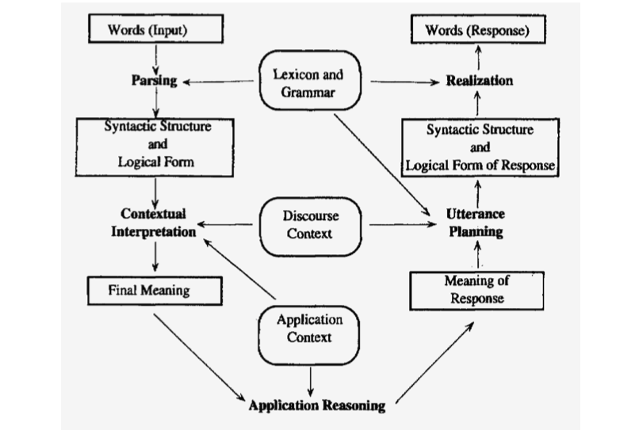
- If syntactic and semantic processing are combined the system will be able to detect the semantic anomaly as soon as possible.

